Open Rectilinear Polygonal Shape
# Source: AI Source: Provided by: [Data Path: Persons Table -> ID Column: 1, Name_En Column: Motasem Essam] -> From: [ChatGPT] on [7/25/2026]
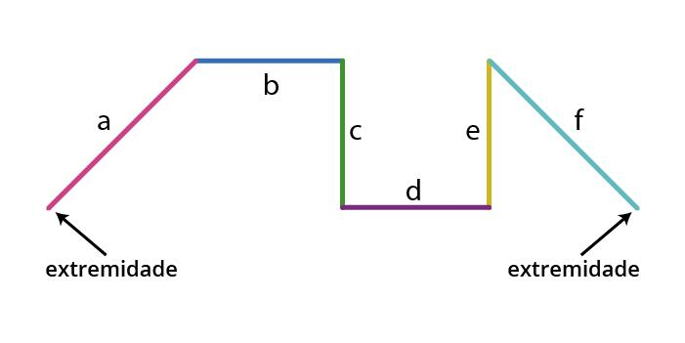
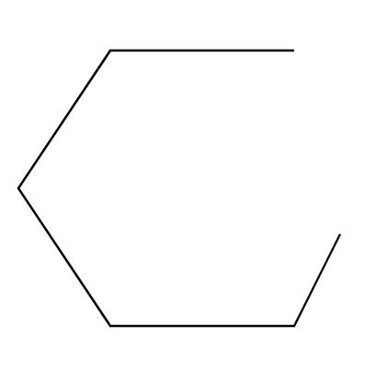

Definition
# Source: AI Source: Provided by: [Data Path: Persons Table -> ID Column: 1, Name_En Column: Motasem Essam] -> From: [ChatGPT] on [7/25/2026]
An Open Rectilinear Polygonal Shape is an open polygonal path made entirely of horizontal and vertical line segments, with consecutive segments connected at right-angle turns and the starting and ending points remaining unconnected.
$$\boxed{\text{Open Rectilinear Polygonal Shape}=\text{Horizontal Segments}+\text{Vertical Segments}+\text{Open Boundary}}$$
Rectilinear means that every segment runs in one of two perpendicular directions: horizontal or vertical.

Characteristics
# Source: AI Source: Provided by: [Data Path: Persons Table -> ID Column: 1, Name_En Column: Motasem Essam] -> From: [ChatGPT] on [7/25/2026]
An Open Rectilinear Polygonal Shape:
- Is open.
- Contains three or more straight segments.
- Uses only horizontal and vertical segments.
- Usually changes direction by ${90}^{∘}$.
- Has two unconnected endpoints.
- Does not enclose an area.
- Can have equal or unequal segment lengths.
- Can be symmetric or asymmetric.
- Can form staircase, zigzag, L-like, U-like, or irregular orthogonal paths.
A simple representation is:
$$\boxed{A→B→C→D}$$
where each segment $AB,BC,CD$ is horizontal or vertical.

Types of Open Rectilinear Polygonal Shapes

1. Open L-Shaped Rectilinear Path
# Source: AI Source: Provided by: [Data Path: Persons Table -> ID Column: 1, Name_En Column: Motasem Essam] -> From: [ChatGPT] on [7/25/2026]
Two perpendicular directions form an L-like open path.
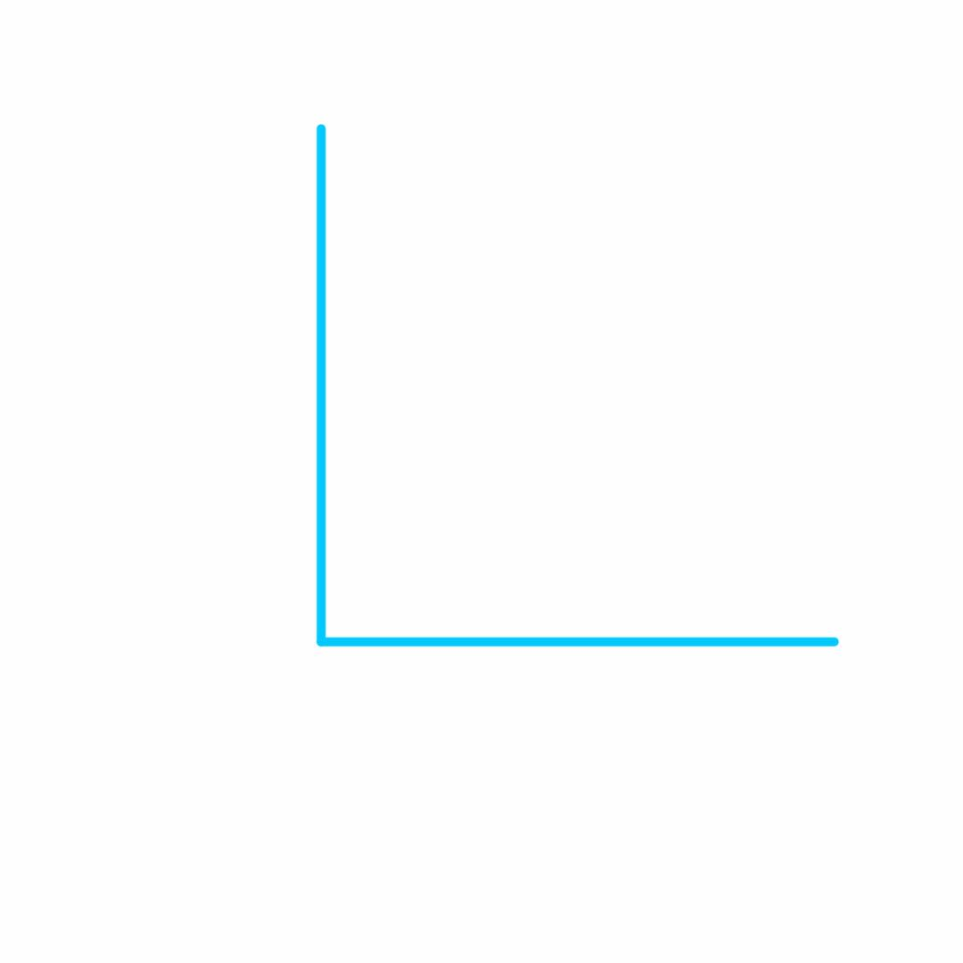
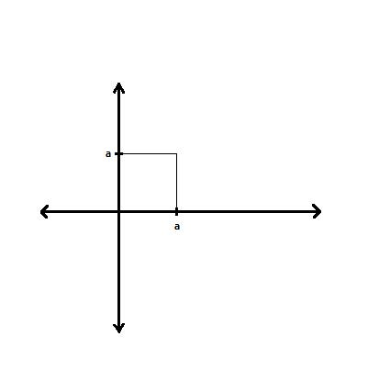
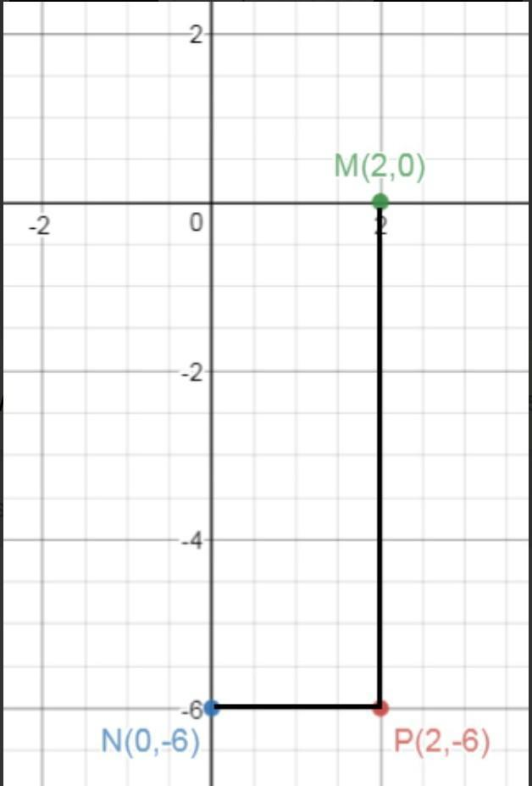
The basic turn is:
$$\boxed{θ={90}^{∘}}$$

2. Open Stair-Step Rectilinear Shape
# Source: AI Source: Provided by: [Data Path: Persons Table -> ID Column: 1, Name_En Column: Motasem Essam] -> From: [ChatGPT] on [7/25/2026]
The path alternates between horizontal and vertical segments to create a staircase appearance.
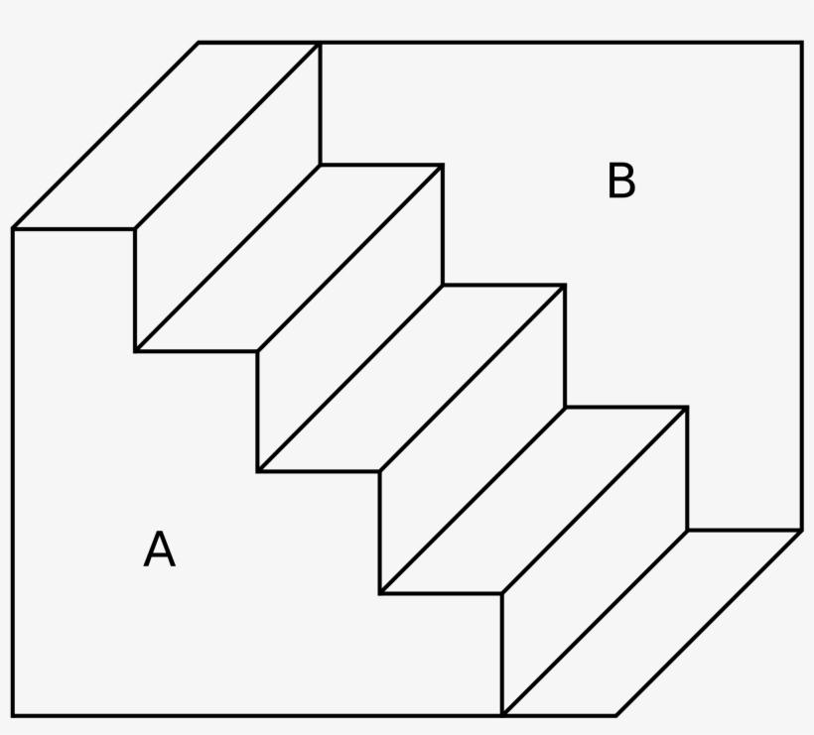
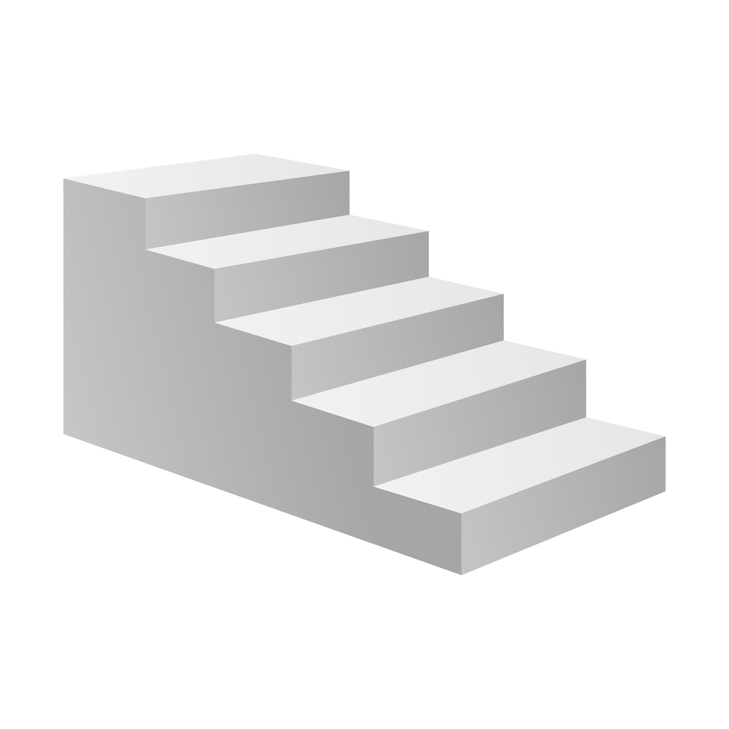
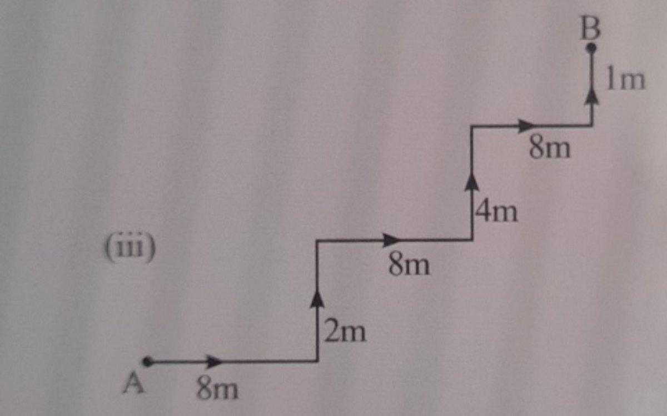
Example:
$$\boxed{→↑→↑→}$$

3. Open Rectilinear Zigzag Shape
# Source: AI Source: Provided by: [Data Path: Persons Table -> ID Column: 1, Name_En Column: Motasem Essam] -> From: [ChatGPT] on [7/25/2026]
The path repeatedly changes between horizontal and vertical directions.
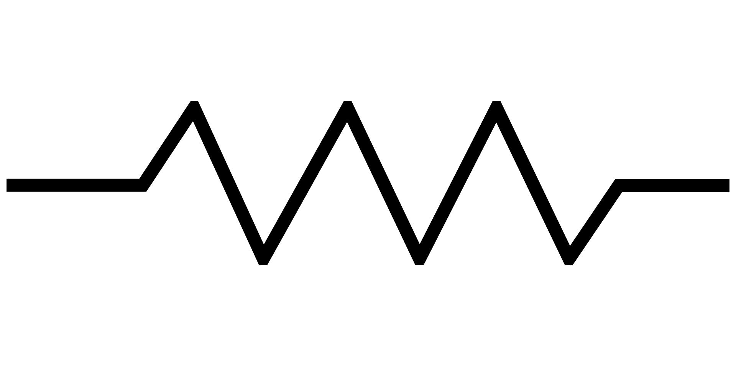
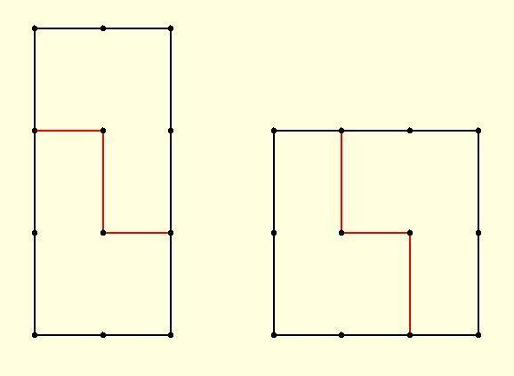
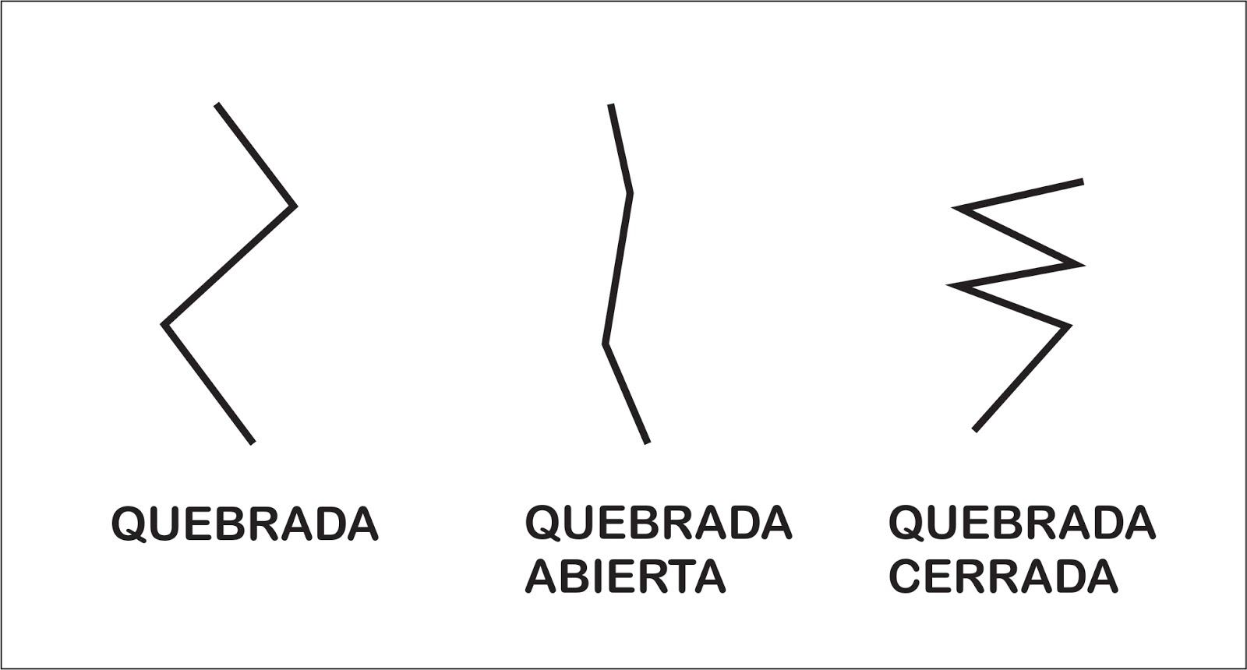
Unlike a diagonal zigzag, every segment remains horizontal or vertical.

4. Open U-Like Rectilinear Shape
# Source: AI Source: Provided by: [Data Path: Persons Table -> ID Column: 1, Name_En Column: Motasem Essam] -> From: [ChatGPT] on [7/25/2026]
Three or more horizontal and vertical segments create a U-like open path.
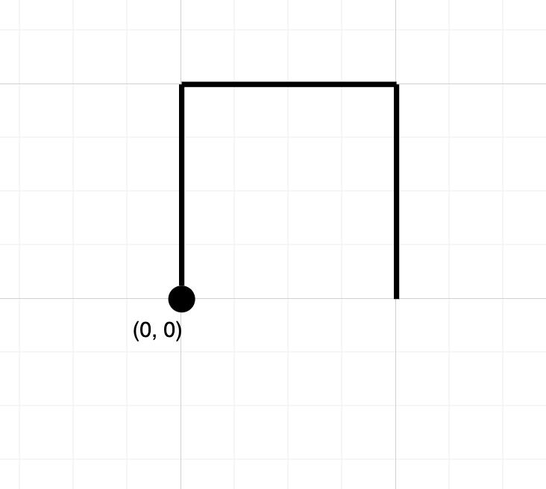
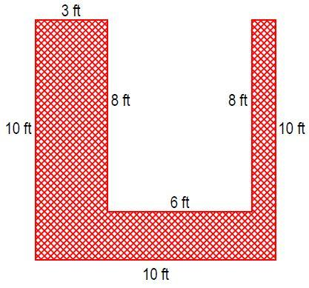
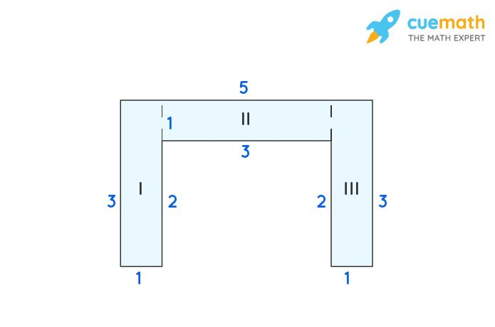
The two endpoints remain separated.

5. Open C-Like Rectilinear Shape
# Source: AI Source: Provided by: [Data Path: Persons Table -> ID Column: 1, Name_En Column: Motasem Essam] -> From: [ChatGPT] on [7/25/2026]
The path resembles the letter C using only horizontal and vertical segments.
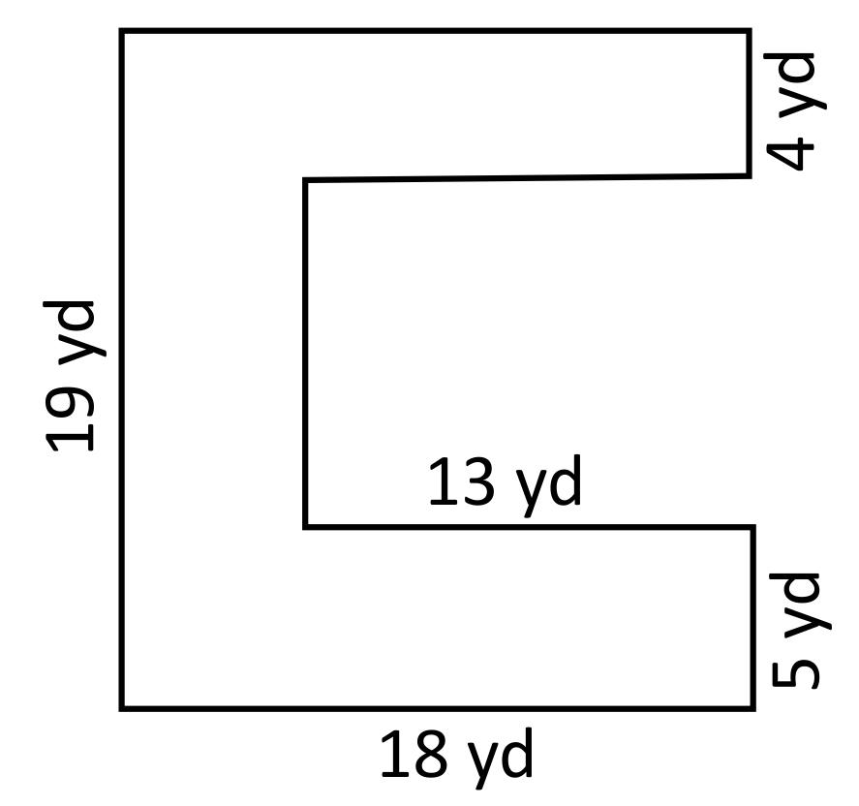
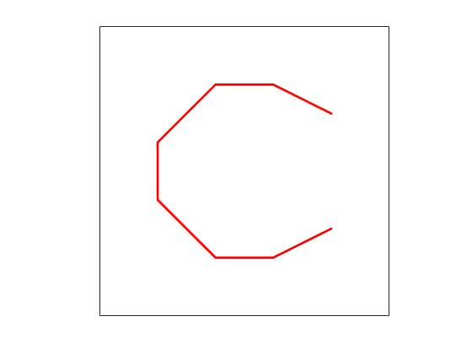
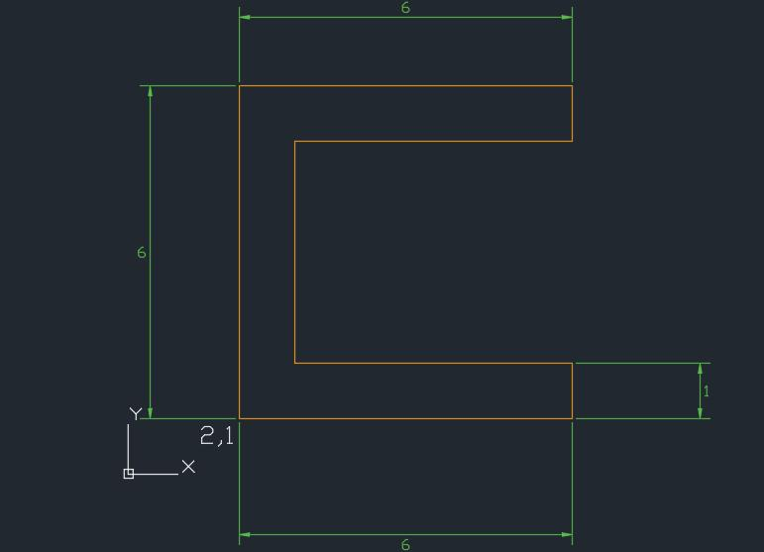

6. Open Rectilinear S-Like Shape
# Source: AI Source: Provided by: [Data Path: Persons Table -> ID Column: 1, Name_En Column: Motasem Essam] -> From: [ChatGPT] on [7/25/2026]
A sequence of horizontal and vertical segments creates an S-like path.

7. Symmetric Open Rectilinear Shape
# Source: AI Source: Provided by: [Data Path: Persons Table -> ID Column: 1, Name_En Column: Motasem Essam] -> From: [ChatGPT] on [7/25/2026]
The horizontal and vertical segments are arranged symmetrically.
The overall figure can have reflection symmetry even though it is open.

8. Asymmetric Open Rectilinear Shape
# Source: AI Source: Provided by: [Data Path: Persons Table -> ID Column: 1, Name_En Column: Motasem Essam] -> From: [ChatGPT] on [7/25/2026]
The segments have irregular lengths and are arranged without symmetry.
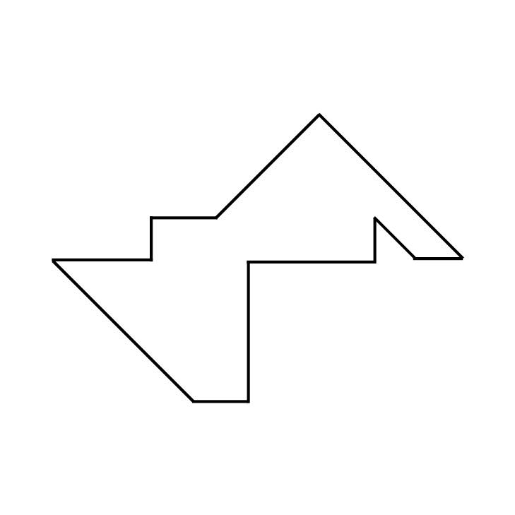
For example:
$$L_{1}≠L_{2}≠L_{3}≠L_{4}$$

9. Equal-Segment Open Rectilinear Shape
# Source: AI Source: Provided by: [Data Path: Persons Table -> ID Column: 1, Name_En Column: Motasem Essam] -> From: [ChatGPT] on [7/25/2026]
The segments have equal or repeated lengths.
Equal lengths do not make the figure closed.

10. Unequal-Segment Open Rectilinear Shape
# Source: AI Source: Provided by: [Data Path: Persons Table -> ID Column: 1, Name_En Column: Motasem Essam] -> From: [ChatGPT] on [7/25/2026]
The horizontal and vertical segments have different lengths.
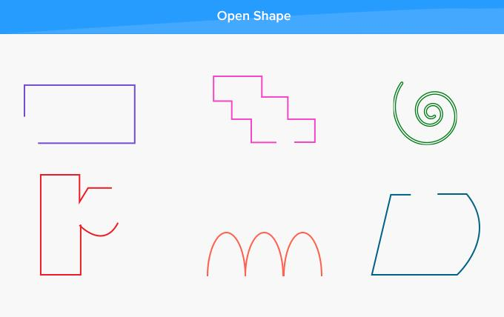
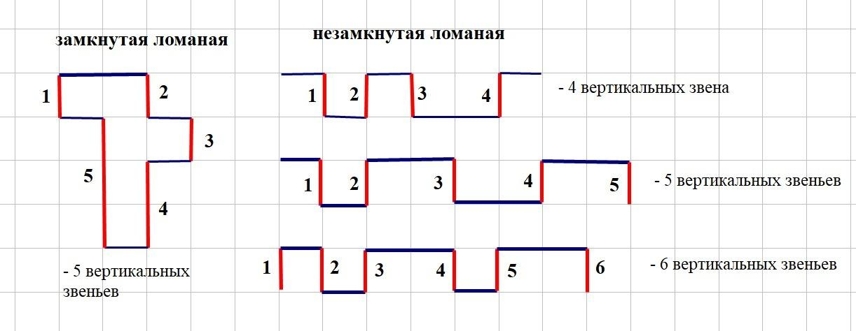
This is one of the most general irregular rectilinear forms.

Open Rectilinear vs. Open Zigzag
# Source: AI Source: Provided by: [Data Path: Persons Table -> ID Column: 1, Name_En Column: Motasem Essam] -> From: [ChatGPT] on [7/25/2026]
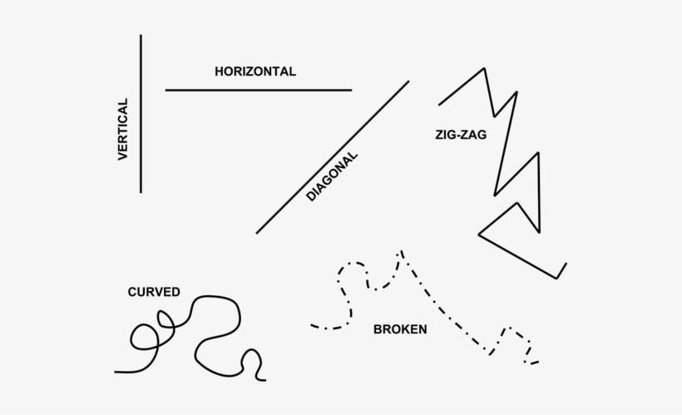
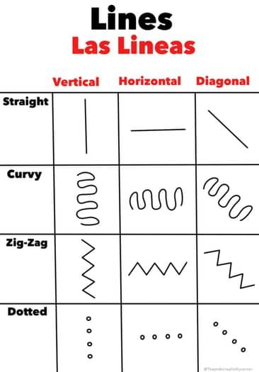
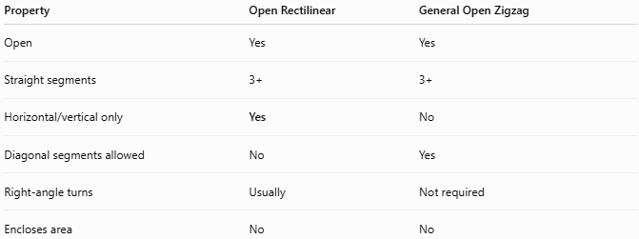
Property | Open Rectilinear | General Open Zigzag
Open | Yes | Yes
Straight segments | 3+ | 3+
Horizontal/vertical only | Yes | No
Diagonal segments allowed | No | Yes
Right-angle turns | Usually | Not required
Encloses area | No | No
Thus, every rectilinear zigzag is a zigzag, but not every zigzag is rectilinear.

Open Rectilinear vs. Closed Rectilinear Polygon
# Source: AI Source: Provided by: [Data Path: Persons Table -> ID Column: 1, Name_En Column: Motasem Essam] -> From: [ChatGPT] on [7/25/2026]
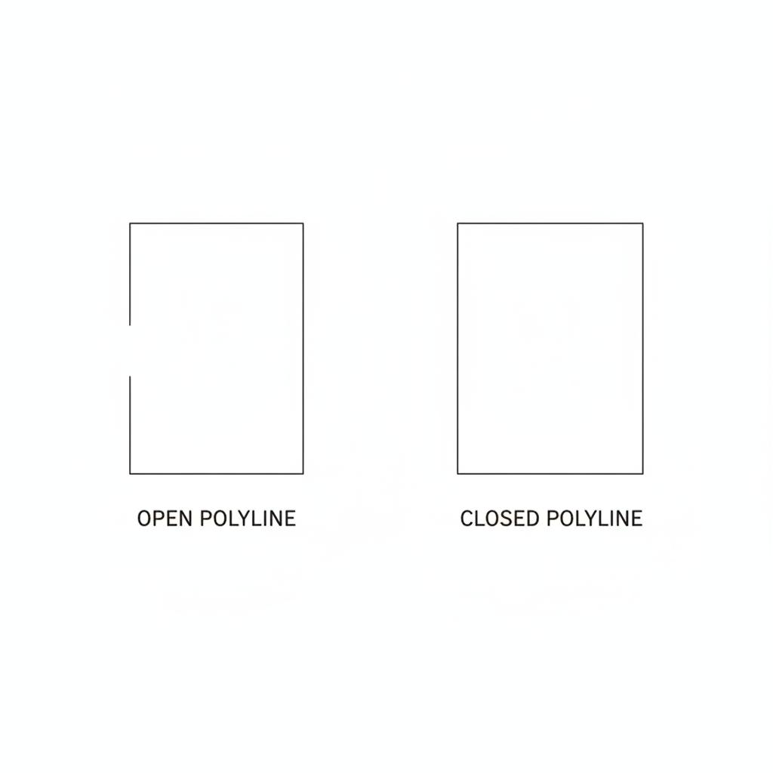
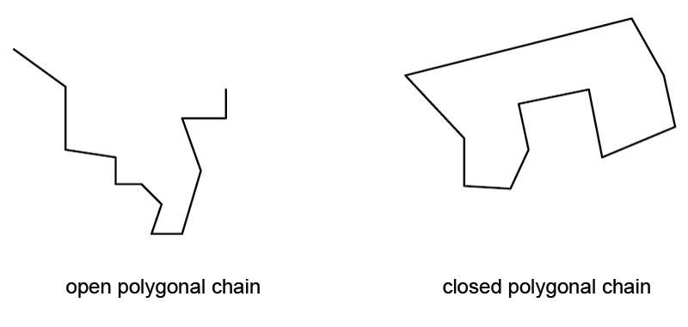
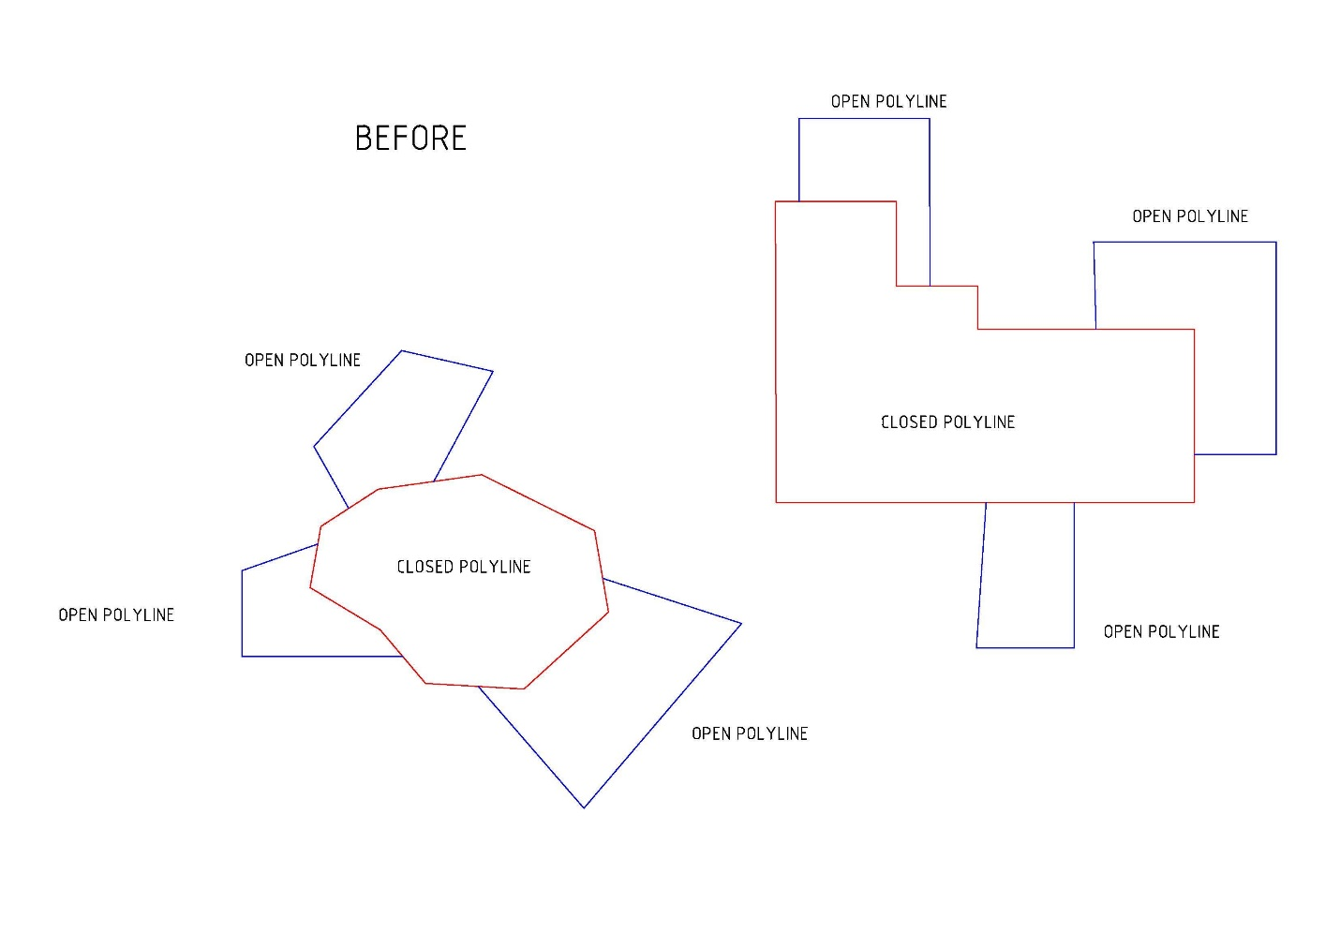

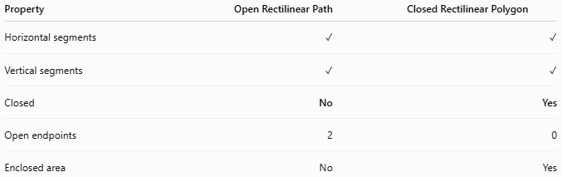
Property | Open Rectilinear Path | Closed Rectilinear Polygon
Horizontal segments | ✓ | ✓
Vertical segments | ✓ | ✓
Closed | No | Yes
Open endpoints | 2 | 0
Enclosed area | No | Yes
A closed rectilinear path can form shapes such as rectangles, orthogonal polygons, and staircase polygons.

Area and Length
# Source: AI Source: Provided by: [Data Path: Persons Table -> ID Column: 1, Name_En Column: Motasem Essam] -> From: [ChatGPT] on [7/25/2026]
Area
Because the path is open:
$$\boxed{A=\text{no enclosed area}}$$
Total Path Length
If there are $n$ segments:
$$\boxed{L=L_{1}+L_{2}+⋯+L_{n}}$$
Since all segments are horizontal or vertical, their lengths can be measured directly from their horizontal or vertical displacement.

Key Points
# Source: AI Source: Provided by: [Data Path: Persons Table -> ID Column: 1, Name_En Column: Motasem Essam] -> From: [ChatGPT] on [7/25/2026]
An Open Rectilinear Polygonal Shape is:
$$\boxed{\text{Open}+\text{3 or More Straight Segments}+\text{Horizontal/Vertical Segments}}$$
It:
- Has three or more straight segments.
- Uses only horizontal and vertical segments.
- Usually has (90^\circ) turns.
- Has two unconnected endpoints.
- Does not enclose an area.
- Can be L-shaped, U-like, C-like, S-like, staircase-like, or zigzag-like.
- Can have equal or unequal segment lengths.
- Can be symmetric or asymmetric.
Most important distinction
$$\boxed{\text{Rectilinear}=\text{Horizontal + Vertical Only}}$$
while:
$$\boxed{\text{Polygonal}=\text{Straight Segments in Any Direction}}$$

Conclusion
# Source: AI Source: Provided by: [Data Path: Persons Table -> ID Column: 1, Name_En Column: Motasem Essam] -> From: [ChatGPT] on [7/25/2026]
Open Rectilinear Polygonal Shapes are open polygonal paths composed entirely of horizontal and vertical line segments. Their defining characteristic is the restriction to two perpendicular directions. They can be further classified according to their path pattern, symmetry, segment lengths, and complexity, including L-shaped, U-like, C-like, S-like, staircase, and zigzag forms.

